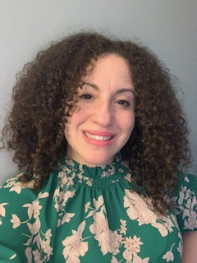

Lissette Ramos LMFTA

LR Psychotherapy Wellness LLC

Lissette has worked in the mental health field for about 10years, starting as a case manager for adults working on their recovery from drug addictions, substance use, and various mental health disorders stemming from schizophrenia, bipolar, major depression, and others conditions. Now as a marital and family therapist, has developed a passion for trauma focused work, supporting those with Nuro divergent brains such as ADHD and expanding interest with helping those with high functioning Autism Spectrum Disorder. Lissette started her path as a therapist working as an intern for the VA doing couples work and therapy for the PTSD clinic with Veterans. After graduating in 2020 gained experience with in-home therapy family work to prevent youth from going in the juvenile system and to support their success attaining their high school diploma. Lissette’s passion is couples, family work, and the overall individual mental health wellness of the human condition. Life is full of complexities and there is no one size fits all treatment. Lissette utilizes various strategies and models to tailor to the client at hand. Depending on the problem/circumstance at hand will take the lead to guide the treatment fostering confidence to the client so that the client can then take their treatment into their hands, establishing a collaborative approach to achieve client goals. If you feel stuck and need a therapist that will challenge your mindset to foster the change to improve your quality of life, this would be the right fit. Lissette is warm, compassionate, flexible, but direct with treatment.

Please contact Lissette via (860) 385-4897 for a free 15min consultation

Currently accepting private pay only, hourly session fee is $125, Sliding scale based on income is available.